Answers
1. Network packets are used to send data across networks.
The network packets contain three sections:
- Header
- Payload
- Trailer
(a) State three components of the header. [3]
Destination address / destination. (1)
Originator’s address / sender. (1)
Packet number. (1)
(b) State one purpose of the trailer in a network packet. [1]
It signifies the end of the packet. (1)
Contains error checking information (such as the CRC/cyclic redundancy check). (1)

2. Look at the following diagram of a network.
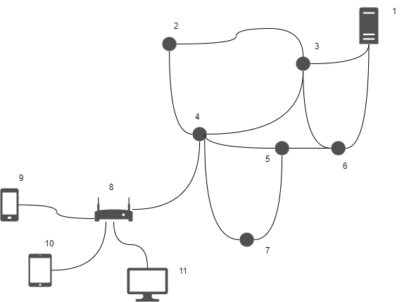
(a) Describe how packet switching is involved in sending data from the computer
(labelled 11) to the server (labelled 1). [4]
The data is broken down into packets. (1)
The packets are sent to the router shown in 8. (1)
Each of the routers on the network then control the route a packet takes / send the packet to a closer router to the destination. (1)
Each packet may take a different route / for example, 11,8,4,5,6,1 or 11,8,4,3,1. (1)
The packets may arrive out of order. (1)
Once the last packet has arrived, packets are reordered. (1)
The router looks at the destination address in each packet to determine the correct router/computer to send to. (1)
(b) A traditional telephone network established a telephone call by connecting dedicated lines together. The telephone customer then has exclusive use of all these lines when making their call.
Explain one advantage of using a packet switched network over a traditional
telephone network. [2]
Packets for many different destinations can be sent through the same connection / router (1) which means that many more users are able to access the network at the same time (1).
Because packets have error checking / CRC at the end of the packet / in the trailer (1) computers are able to request that incorrectly sent packets are re-sent (1) making it more reliable when sending data that needs to be perfectly transmitted (1).

[Total 10 marks]

